WEB PROJECT REPORT

Name: Niall Sheerin

Student Number: s00200760

Class : Group C

INTRODUCTION :

This is my 50% Web Design Project . My project was based off the sport of Gaelic football. The main reason I picked this topic is due to the fact that I play the sport myself and that I find both the history and the physical attributes very interesting.

The audience I designed this website for are for every age group in mind, but mainly for people that play the sport and enjoy the work behind it.

GIT-HUB URL:

This is the link to my website via github;

<https://niall-sheerin.github.io/Web-Design-Project/>.

This is my repository url:

DESCRIPTION:

Home Page: This is the welcoming page for the website and allows you to join the website or login if you have previously

VALIDATION:

1: Index Page

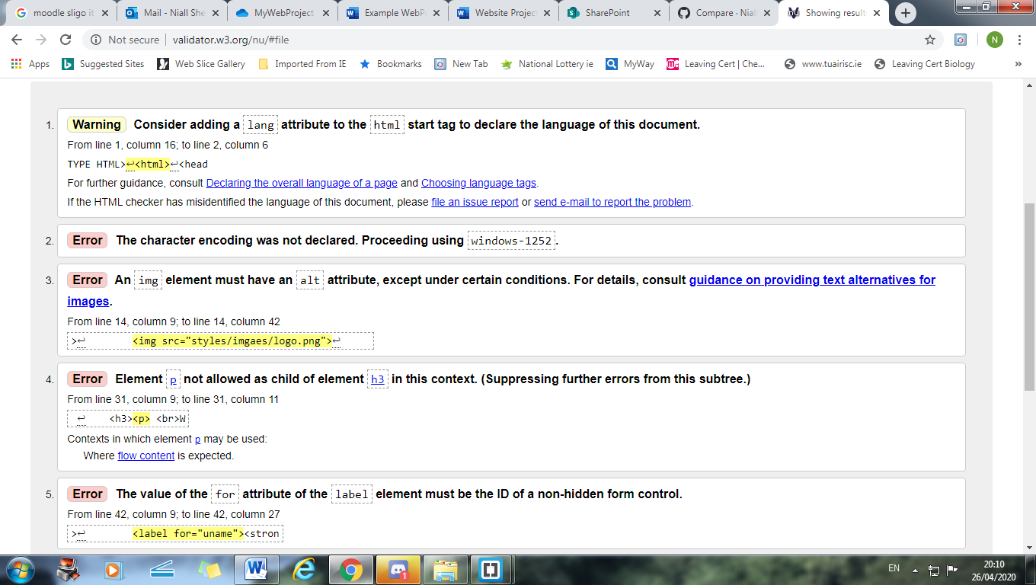

Page 2: Physical Page

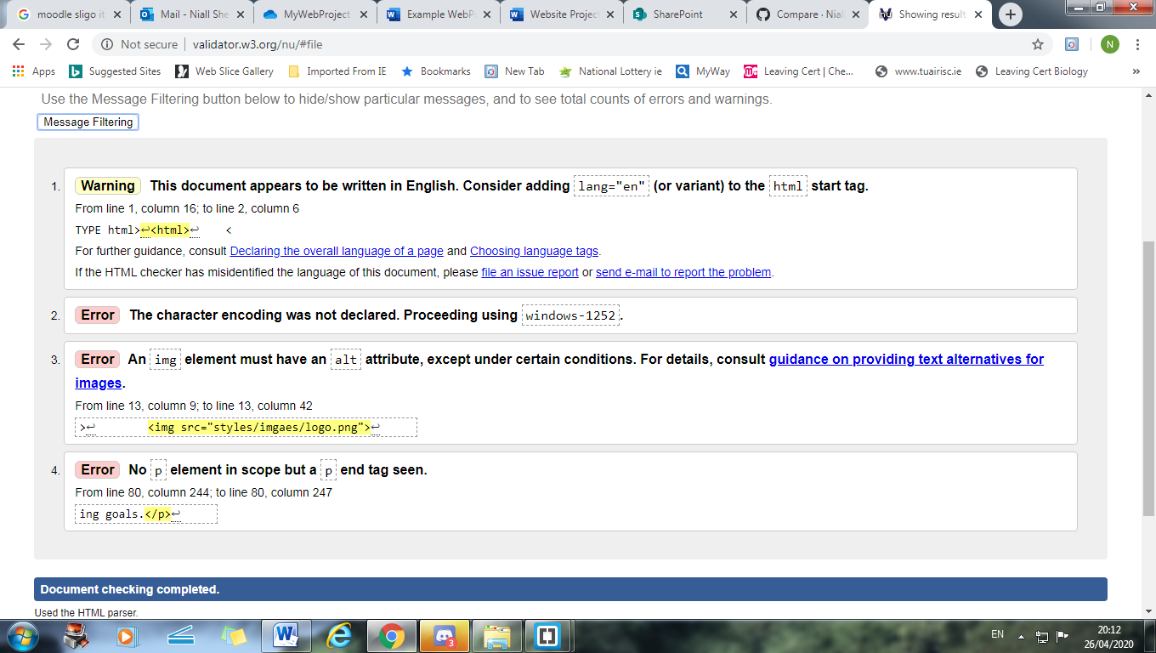

Page 3: History Page

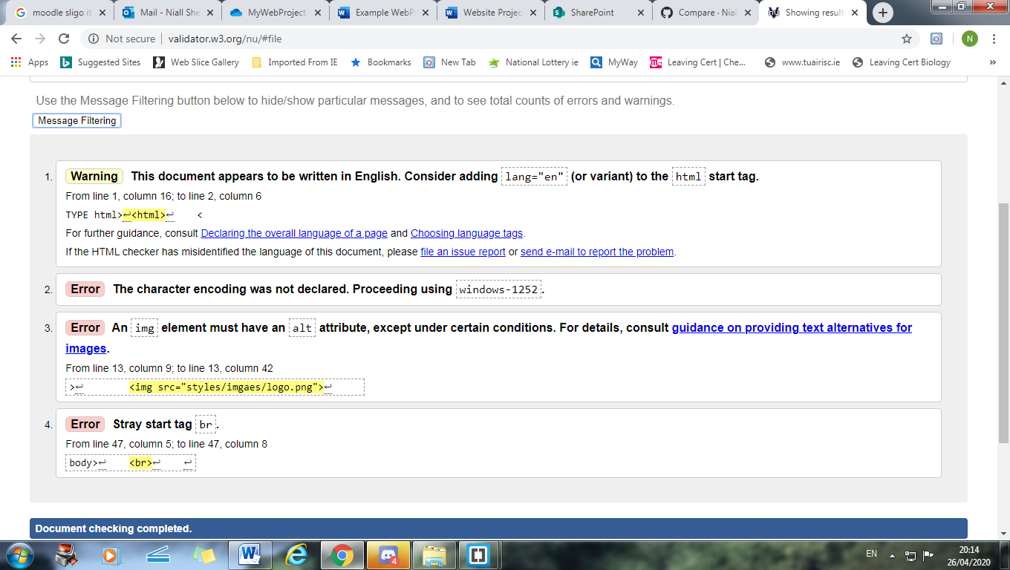

Page 4 : Contact Us

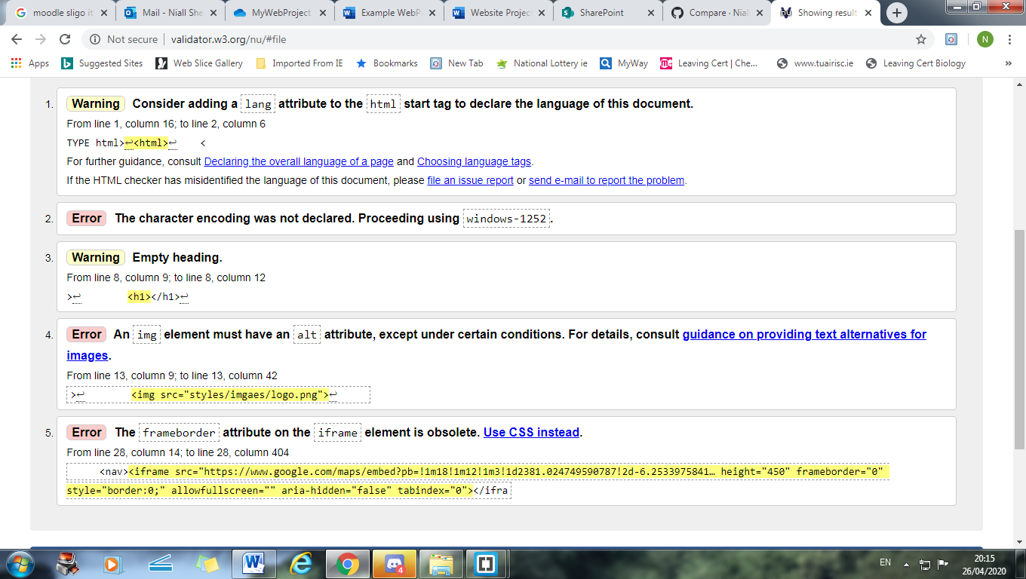

CSS VALIDATION:

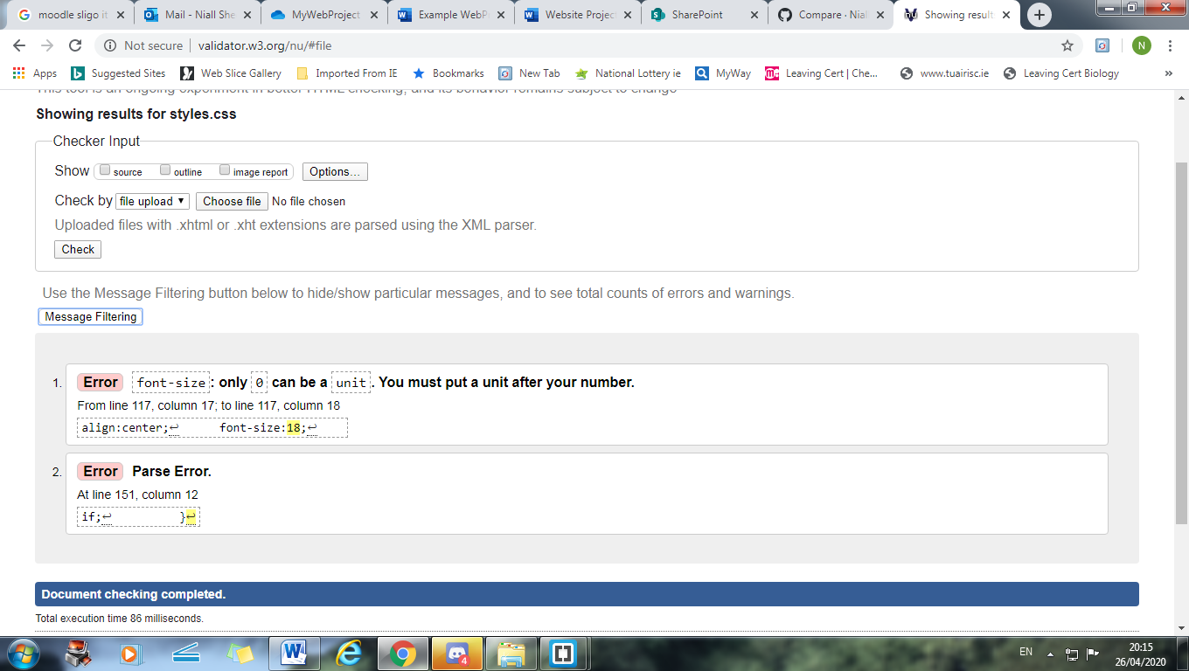

WEB PAGE CHECKLIST:

|  |
| --- |
| **\*\*\*\*Must include Report including purpose and intended audience of the website and sources of images and information of each web page and HTML & CSS validation results. Upload completed project include url in report** |
| **Minimum of 4 HTML Pages with navigation menu not dummy text, use text and hyper link from appropriate website** ( outline college project on landing page, do not include any personal or college information in the content of the pages) |
| **Upload progress and completed website to your GitHub account** |
| **HTML5 standards and recommended page layout structure** (header,main,aside,article,footer,etc) |
| **Include appropriate Meta data – description & appropriate keywords etc to improve pages SEO** |
| **Include font family for web page body** |
| **Appropriate use of External Style Sheet – Recommended CSS (**standard for majority of your CSS) |
| **Appropriate use of Internal & Inline Styling on HTML page** (one example of each) |
| **Home page content aligned to each other and visually attractive** |
| **Include navigation above fold and bottom of web pages- Indicate on navigation the current page** |
| **Include both Class and ID as CSS Selectors** |
| **Consistency of design on all pages , use of fonts, colour etc** |
| **Appropriate use of Headings (h1, h2, h3, h4)** |
| **Appropriate use of Colours (test for colour blind users)** |
| **Include an article or section with 2 or 3 columns** (by using appropriate css) |
| **Include logo and display in header of page** |
| **Clear, consistent and align content on all pages** (reference all sources) |
| **Include images (with at least one image floated with text alongside)** |
| **Use of background image** |
| **Include table of data/information only for statistical data** |
| **Include lists ordered or unordered (different shaped bullet points)** |
| **Include a link to a suitable video and google map –** use iframe code from YouTube or google maps from share, embed, copy iframe into your html page |
| **Include a contact me form and include red * beside required/mandatory input fields** |
| **Verify data collected on contact form, using get and data attached to URL** (Use the method get to display values entered on form will be appended to url and passed to server <form action=" [http://year1.ccpdev.me/FormTest.php](http://year1.ccpdev.me/FormTest.php?fdf=fdsaf&fdsfs=hfdsahfkjhfa)" method="get"> |
| **Footer information including Copyright© 2020 and navigation** |
| **Internal anchor Links on one of the webpages** |
| **External Link to external website** |
| **Any Additional Features included __________________** |
| **Results included in report of HTML5 Validation (with majority of issues addressed)** |
| **Results included in report of CSS Validation (with majority of issues addressed)** |
| **☐ Include Favicon on the Title tab** | |
| **Guide line on Website appearance, design and Content** [**https://webdesignledger.com/10-signs-of-a-user-focused-design/**](https://webdesignledger.com/10-signs-of-a-user-focused-design/) | |
| **Guidelines on Website overall appearance & design** [**https://webdesignledger.com/20-dos-and-donts-of-effective-web-design/**](https://webdesignledger.com/20-dos-and-donts-of-effective-web-design/) | |